Basic Info.
Project Title - An Analysis of the Clinical Factors Leading to an Increase in Traumatic Injury
Project Repository - https://github.com/calder-lake/Team_Inversion_Project
Laura Sinden - laura.sinden@utah.edu - u0098758
Caitlin Roake - caitlin.roake@hsc.utah.edu - u1601679
Calder Lake - U1049486@utah.edu - u1049486
Tyler Huyette - tyler.r.huyette@hsc.utah.edu - u0850428
Stephanie Ehlert - stephanie.ehlert@hsc.utah.edu - u0473845

Background and Motivation.

Trauma is the leading cause of death in the United States for adults under the age of 50 and the primary contributor to years of life lost (1). While death rates from chronic diseases such as cancer and heart disease have been overall declining, mortality related to traumatic injury has actually increased in the last decade relative to population growth (1). There are several theories to this increase in mortality from traumatic injury. An aging population in the United States is at greater risk from significant trauma due to falls and other seemingly minor mechanisms. Many older adults have co-existing comorbidities that may predispose to longer hospital stays and increased mortality after trauma. Our central hypothesis is that the increase in trauma mortality is driven by older age groups, minor mechanisms such as falls, and increased comorbidities in trauma victims as well as an increased number of potentially harmful prescriptions in these individuals such as blood thinners, beta blockers, and sedative medications.

There are a number of scoring systems and outcomes with which to investigate trauma severity and impact on victims' hospital courses. Simple measures include measuring whether a patient is discharged alive or deceased or looking at whether they are well enough to be discharged home or have functional impairments requiring discharge to a skilled nursing facility or other long term acute acute care facility. More complex measures include the injury severity score (ISS), Glasgow Coma Scale (GCS) at time of discharge, and Revised Trauma Score (2). We predict that older adults with trauma will have increased severity of trauma as reflected in these scoring systems.

Our motivations for pursuing this project are based on our backgrounds and current research interests. Many members in our group are interested in working with health datasets such as those aggregated by electronic health records. An investigation into trauma patients will require use of such databases. Other members of our group are interested in growing our programming skills. Some of us are learning how to interrogate databases using R, Python, and Stata and are interested in the relative strengths and weaknesses of these tools for performing clinical inquiries. The author of this section (Caitlin Roake) is an emergency medicine physician and sees many trauma patients in the course of their job. Further, this author is a member of the Acute Care and Translational Research Laboratory at the University of Utah working on a project on early interventions in traumatic injury to improve patient outcomes which requires a deep understanding of the factors contributing to increased trauma burden in the Emergency Department.

Project Objectives. Provide the primary questions you are trying to answer with your data. What would you like to learn and accomplish? List the benefits of how the data could be useful.

We propose looking at Utah’s, the National trauma registry, or both and asking some questions about the data. These questions include:
- How is the Utah data different from the national data in terms of patient age, comorbidities, trauma severity, trauma mechanism, etc.
- Can you predict trauma severity in either dataset by age and mechanism of injury?
- Can you predict trauma severity in either dataset by initial EMS vital signs?
- We could try and re-create this paper using the same methods (CDC database)
Comparison groups:
Adults 18-65, Adults 65+

Primary Outcomes:
- Comparison of injury mechanisms between young adults and older adults
- Comparison of trauma severity between young adults and older adults (as measured by length of stay, discharge metrics, readmission rates, and trauma severity scoring)

Secondary Outcomes (Utah specific):
- Comparison of injury mechanisms between young adults and older adults in Utah
- Comparison of trauma severity between young adults and older adults in Utah (as measured by length of stay, discharge metrics, readmission rates, and trauma severity scoring)

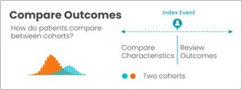

Figure 1: An example of cohort functionality in TriNetX

Data:

- TriNetX will be our primary source of data.TrinetX contains extensive data on trauma and is available to University of Utah Researchers. TrinetX contains the ability to build patient cohorts which will be essential to our primary research question.

- National Trauma Data Bank will be a supplemental source of data depending on our ability to access this dataset (request has been sent). This database contains data on national trauma admissions from 2007 - 2024. This is a comprehensive database which is oriented towards trauma researchers and contains data on frequently used trauma scoring systems such as the ISS pre-calculated.The types of data contained in this database are here: NTDS Data Dictionary 2017.pdf

- Utah Trauma Registry will be a supplemental source of data depending on our ability to access the dataset (request has been sent). This data source is modeled after the NTDB but specific to Utah. The types of data contained in this database are here 2010_TUGDataDictionary_5_0.pdf

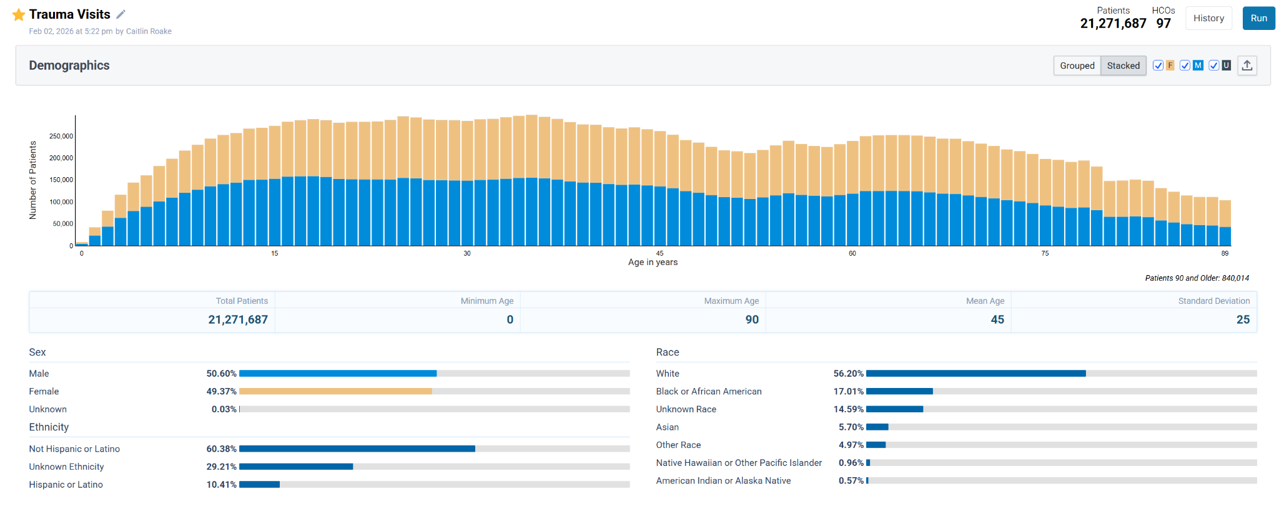
Figure 2: A visualization of data available from TriNetX

Data Processing.

Since the dataset that we are going to be using as our primary resource for information on traumatic injuries in Utah is a clinical dataset, a thorough data cleaning will likely be required to analyze the available data appropriately. In addition, health data may also require certain inferences to be made based on the available standards used for coding a patient’s health information. We anticipate deriving metrics such as monthly or yearly averages in traumatic injuries and types of traumatic injuries to better appreciate the changes at the population and health system levels that are contributing to the observed increase in traumatic injuries. This will likely require summary statistics to be taken on the demographics of patients that are treated for traumatic injuries, comorbidities, medications taken at the time of the encounter, and mechanism or types of injury where available. Data visualization will also allow comparison of traumatic injuries in Utah to those in other parts of the US.

Due to the group’s interests in programming, data cleaning and processing may take on a variety of forms. R and/or Python will be used for data cleaning and analysis. Stata is another tool that the group intends to use to assist in data analysis and visualization. To ensure the integrity of the source data, an original version of the data will be stored in a GitHub repository. In addition, a cleaned version of the data will also be available in the repository on which analysis using the above tools can be performed without fear of overwriting the source data. Responsible version control practices will be implemented using Git so that changes to the data can be tracked and the group can avoid repeating or overwriting data processing conducted by another group member.

Design. The goal of our data will be to visually answer the questions asked above:
How is the Utah data different from the national data ?
Can you predict trauma severity in either dataset by age and mechanism of injury?
Can you predict trauma severity in either dataset by initial EMS vital signs?
Must have: Data should visually tell the story of our research. It should be interesting to look at and easy to figure out what is going on and what the visual goal is.

We could use a heatmap of the US plotting incidences of trauma in using our comparison groups; individuals 18-65 and 65+
Example of US population heatmap
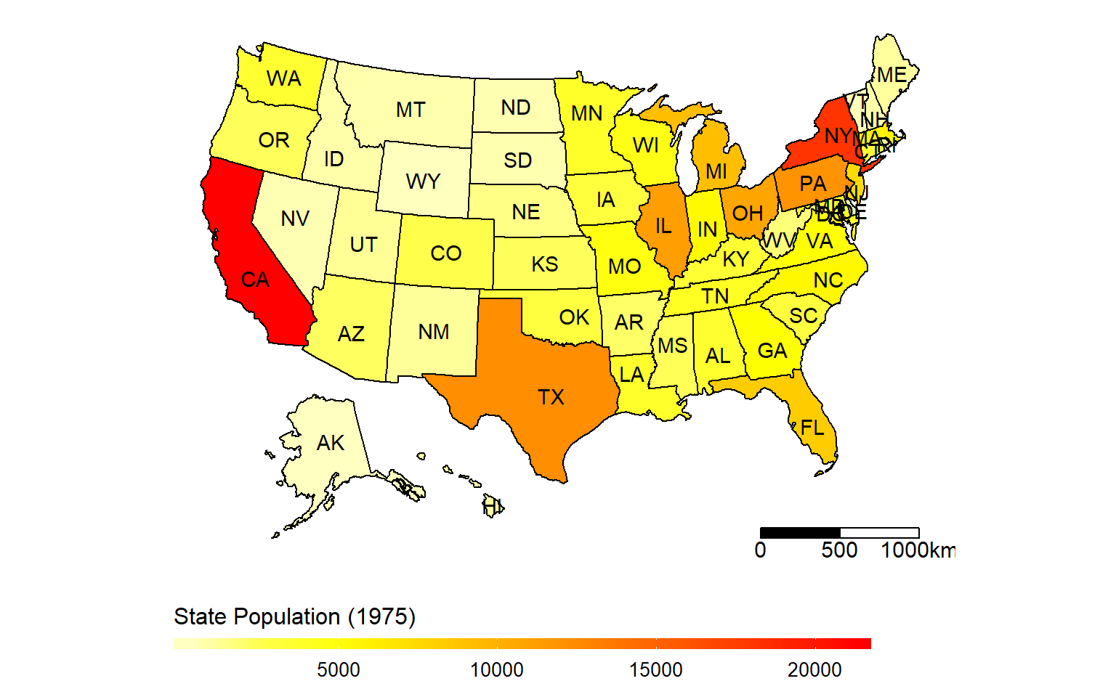

We could use a gaussian distribution graph for possibly predicting trauma severity vs EMS vital signs.

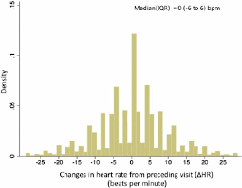
For trauma severity by age and mechanism of injury we could use a scatter plot
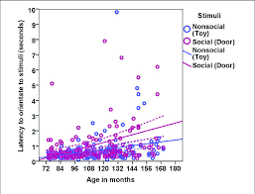

\
These are all just ideas. When we analyze the data, the story may be told more effectively with type of graph not pictured here.

Project Schedule.

Feb 1: Schedule meeting with instructors to go over the proposal. Work as a group to find the best time for this.

Feb 8: Data quality analysis begins and work stored in the GitHub Repository. Discuss as a group any issues or problems encountered with the data.

Feb 15: After reviewing our initial analysis as a group, further analysis will be assigned within the group. Powerpoint presentation started.

Feb 22: Evaluate our current progress on the data quality analysis and any other data analysis that has been conducted. Create a plan for how we want to present our progress in class. PowerPoint does not need to be completed by this point.

Mar 1: Give our progress presentation in class. Discuss the peer feedback given and make any needed adjustments to our project plan. Discuss our progress at this point, so we are ready to submit our project progress after Spring Break. Make assignments, as needed.

Mar 8: Give our brains a rest on Spring Break

Mar 15: Submit project progress on GitHub. Continued analysis, if needed, based on peer feedback.

Mar 23: Evaluate our current progress on the data quality analysis and any other data analysis that has been conducted. Create a plan for how we want to present our progress in class.

Mar 30: Give our 2nd progress presentation in class. Discuss the peer feedback given and make any needed adjustments to our project plan. Make assignments, as needed.

April 6: Compile all content and get it ready for the final presentation. The PowerPoint presentation should be near the final draft by the end of this week.

April 13: Discuss as a group how we will conduct our final class presentation.

Prior to April 21: Any last adjustments should be made and the final project uploaded.

This proposal is the first part of your process book. As a ballpark number: your proposal should contain about 3-4 pages of text.
You will schedule a project review meeting with a staff member during regular lecture times of the week marked in the schedule. Make sure all of your team members are present at the meeting.
The proposal will be submitted by uploading it to your team’s GitHub repository.

References

1. Evolving Epidemiology of Increasing Trauma Deaths in the United States (2000-2020)Evolving Epidemiology of Increasing Trauma Deaths in the United States (2000–2020).pdf
2. https://www.orthobullets.com/trauma/1055/trauma-scoring-systems
3. Mechanisms of traumatic injury by demographic characteristics: an 8-year review of temporal trends from the National Trauma Data Bank

